|  |  |
| --- | --- |
| HKU Computer Science Undergraduate  Reynard verill buntoro | **Phone**: (852) 9775 8170  **Email**: reyvb24@gmail.com  **Personal Website**: https://reyvb24.github.io/Personal-Website/ |

# EXECUTIVE SUMMARY

* Aspiring Data Scientist and HKU Computer Science undergraduate (expected graduation in 2023) keen to pursue career in Technology and FinTech. Awarded HKU Entrance Full-Ride Scholarship in 2019.
* Adept at leveraging advanced proficiency in data analytics, automation, data visualisation and front-end web development to identify process optimisation opportunities and implement solutions that drive enhanced productivity.
* Proven track record of working with teams to design technology-driven solutions. Passionate tech evangelist who can translate complex technical concepts into layman terms for wide range of audiences.

# KEY SKILLS

Software Development • **App Development** • Automation • **User Experience** • Front-End Development • **Data Science** • Machine Learning • **Process Optimisation** • Stakeholder Management • **Leadership and Mentoring** • Problem Solving • **Strategy Management**

**Technical Skills**

Python • Python Pandas • C++ • JavaScript • Java • R • HTML • CSS • SQL • Google API • Selenium • R Shiny • Adobe Photoshop • Procreate • Django • React JS • Visual Studio Code

# PROFESSIONAL EXPERIENCE

summer intern / software Engineer Intern Jun 2021 – August 2021

**Preface Coding, Hong Kong**

*Preface Coding is an award-winning coding school for students of all ages and occupations, who selects only the top 1% of instructors equipped with both industry experience and academic acumen.*

* Lead groups of 5 students aged 9-16 years old in intensive 1-week coding bootcamps, ensuring 100% passing rate. Modules taught: Python Intermediate, Python Beginner, Python Turtle, Frontend Intermediate, Frontend Beginner, App Inventor Intermediate.
* Generate student learning reports at bootcamp midpoint for parents to track students’ detailed learning progress.
* Devise innovative, engaging approaches as part of the Training & Curriculum Development Team to teach technical concepts to beginners, such as designing new projects daily during bootcamp to encourage learning based on practical applications.

**Significant Achievements:**

* Initiated automation of 50 students’ Roblox account creation and tutorials in Codekingdom Platform with Selenium in Python, enabling students to directly designing custom projects, and reducing total time taken for one account creation and introductory tutorial completion to 15 minutes.
* Saved 30 man-hours weekly by developing automation scripts to generate students’ learning reports, as compared to previous manual process. Automation resulted in >100 reports created in Google Docs in a week.
* Successfully collaborated with Product Development Team of 6 to build different APIs for Preface’s upcoming mobile coffee app.
* Nominated as representative speaker for intern feedback sharing session with CEO.
* Achieved 100% intern evaluation score in both technical and non-technical assessments like being self-driven and independent.

Programming INtern Sep 2021 – Present

**Siemens, Hong Kong**

*Siemens AG is a German multinational conglomerate and a focused technology corporation headquartered in Munich and the largest industrial manufacturing company in Europe with branch offices abroad..*

* Currently working on automation projects for water freight custom clearance documents using UIPath.

HEAD OF MARKETING 2020 – 2021

**Hackathon Society, Hong Kong University**

*Hong Kong University is a public research university ranked 1st in Hong Kong and 22nd globally in the 2021 QS rankings.*

* Successfully organised AWS-sponsored hackathon event and managed social media marketing efforts on Instagram, achieved university-wide outreach and converted 100 participants.
* Managed subcommittee of 2 members to spearhead marketing initiatives across various events, including creation of marketing materials like animations, posters and email blasts to maximise response rates.

STUDENT AMBASSADOR 2020 – Present

**Hong Kong University**

* Represented university to provide admissions information to potential incoming students during Info Day.
* Volunteered as mentor for buddy programme.

# PERSONAL PROJECTS

* **S&P500 Index Data Visualisation:** Conceptualised and built data visualisation algorithm on R and Shiny to allow investors to predict monthly returns and dividend yields in S&P500 US stock market index according to its historical performance.

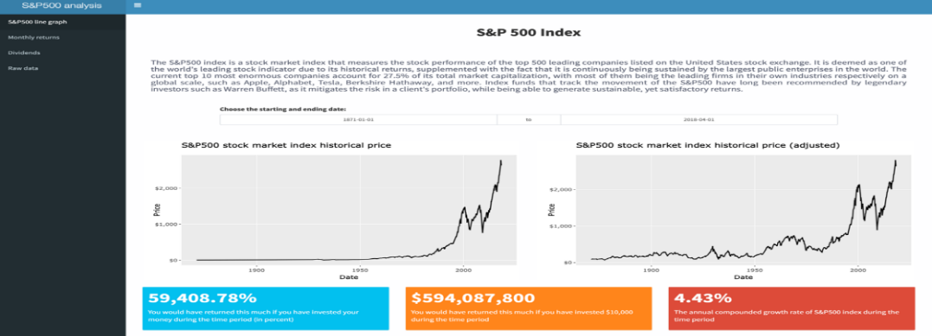

* **Garuda Hacks Hackathon Project:** Collaborated with team of 4 to design prototype mobile app that reduces customers’ purchasing costs by enabling community bulk purchases.

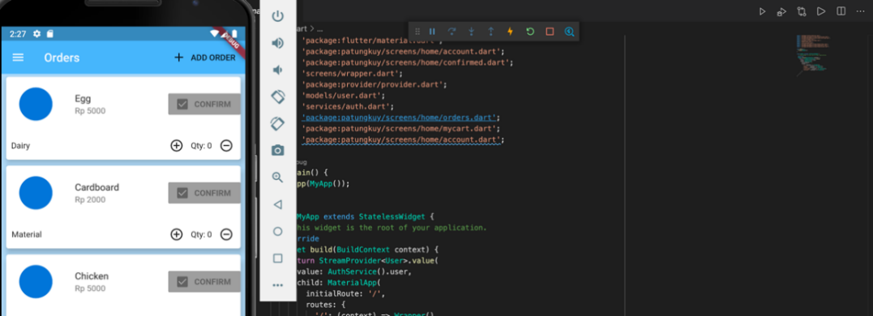

* **Time Series Forecasting Project (HTML report)**: Successfully completed 3rd capstone project for Algoritma Data Science Bootcamp by applying AI forecasting algorithm to predict seasonality in food and beverage sales.

# EDUCATION AND CERTIFICATIONS

BACHELOR OF ENGINEERING – **Major in Computer Science**

*Hong Kong University* – Hong Kong – Ongoing (expected completion in 2023).

Awarded HKU Entrance Full-Ride Scholarship in 2019-now. GPA: 3.55/4.3.

Achieved highest grade of A+ for ENGG1330: Computer Programming I.

data science bootcamp

*Algoritma* – Indonesia – Feb 2021

Successful completion of 3 capstone projects with grade of 91.4%.

Completed additional 7 out of 9 HTML report projects. Available on Github with starting names as LBB on the repositories.

FINANCIAL MARKETS

*Coursera* – Yale University – 2020

BUILDING WEB APPLICATIONS

*Coursera* – University of Michigan – 2020

C++

*LinkedIn Certification* – 2021

R

*LinkedIn Certification* – 2021

PYTHON

*LinkedIn Certification* – 2021

# MISCELLANEOUS INFO

**Nationality:** Indonesian

**Languages:** Fluent in English and Bahasa Indonesia

**Availability:** Immediate

**Co-curricular Activities and Achievements:** FIDE Chess Rating for Blitz (Official Rating by International Chess Organisation): 1495.